# Installation

In order to install the app, please download and unzip the entirety of GitHub repository at <https://github.com/LeszekGzik/Sharepoint-Mailing>. The **Run** shortcut, located in the application’s root folder will automatically run the application. If it doesn’t work, delete the *config.xml* file from the folder and try again.

# Necessary files

In the application’s root folder there’s a file called *ZSOX report template*. **Do not delete this file**, as it is required for the proper functioning of the program. You can, however, modify the pivot table in this file – this will, in turn, change the way final reports are generated in the app.

In the same root folder, a subfolder named *Reports* can also be found. All reports generated during the program execution will appear in this folder.

# Controls

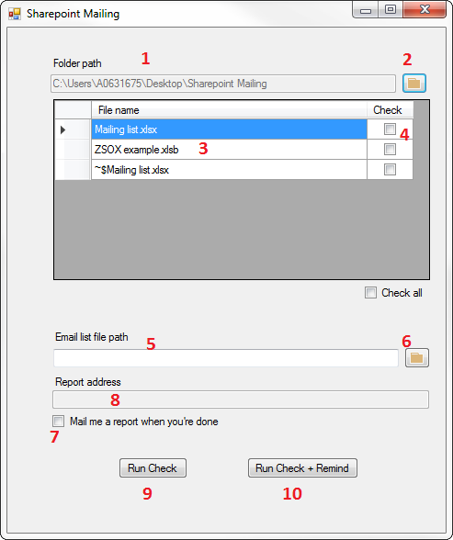

Firstly, select a folder from which the files should be read (1). This can be done by pressing the button on the right (2). After selecting a folder, the list below will be populated with all the Microsoft Excel spreadsheets in that folder and all of its subfolders (3). If you want to process a particular file, check a checkbox in the rightmost column (4).

You should also input a path to the file containing user data and addresses (5). This can be done by pressing the button on the right (6). Providing this file path is **obligatory**, even if you do not intend to use the reminder function. This is because other data is also read from this file, such as full names and surnames of users and team leaders.

At the end of the program’s execution, a complete report will be generated, detailing all the errors found in the checked file(s). By checking a checkbox below (7), one can decide whether or not they want to receive the report via e-mail. If the checkbox is checked, the report will be sent to the address above (8). If not, the report will still be kept in the *Reports* folder.

Once all options are set up, you can begin the check by clicking the „Run Check” or “Run Check + Remind” button (9, 10). Clicking “Run Check + Remind” will send an extra copy of the generated report to all users who have at least one missing value in any of their files.